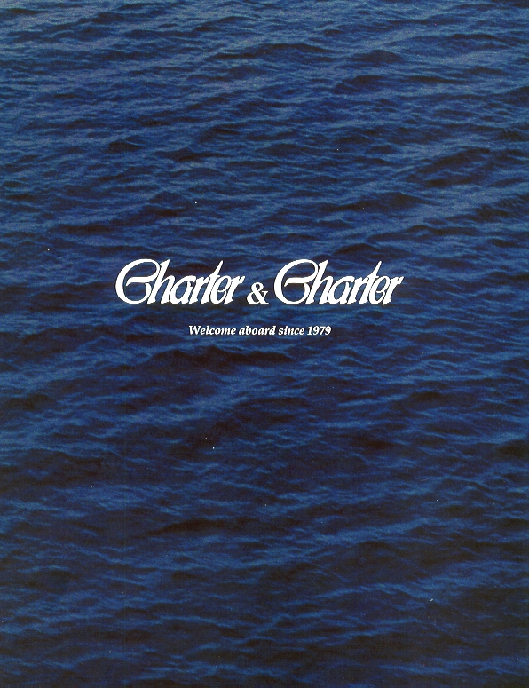

Charter & Charter 25 Years
Making Yachting A Pleasure !

PRESS RELEASE

Charter & Charter celebrates its 25th Birthday this year.
All of Charter & Charter’s Staff are proud to be part of a mature, renowned & highly professional Chartering Company.
Sales, Hire, & Management of Luxury Yachts are the core of Charter & Charter activities. These Services benefit from Charter & Charter’s personalised dedication to All of our Clients – Personal Services which go well beyond the usual basic contractual engagement; they also include expert professional advice & brokers’ attentive analyses.

Mario Liquori, President of Charter & Charter, comments this 14th Monaco Yacht Show & the Luxury Yacht sector :«It must be said that despite the current geopolitical problems & generally morose economic climate, the European Yachting market continues to experience a notable expansion. Activity in 2003 was the highest it has been for ten years !»

Why such a renewed success for Pleasure-Yachting ?
Perhaps such a tendency is due to more intense, & sometimes stressful, life-styles. The need to balance contemporary hyper-active involvement with leisure periods & pass-times : sea-voyages, in comfort, visiting other horizons securely. Owning or chartering a Yacht may be a little of all of that !

Leisure-Yachting is now more Hi-End Selective

Clients are looking for high-quality products, with the accents on luxury & design. Ship-builders must therefore offer vessels which are high-tech & demonstrably modern.
Charter & Charter has evolved with the times – the company has 25 years solid experience to back up its modernity. Charter & Charter offers Best of Service and Best of Brokers. Our Assistance is personalised for Each Client, whether that be in the field of Chartering or of Sales. Our Professional Advisory Services are particularly vigilant concerning the construction of new vessels & the follow-up surveillance of such work.
Because of its professionalism, Charter & Charter has seen its turnover 2003/2004 increase by 35 % compared to the preceding year’s results.
The company’s clientele is 80 % International : The USA, Italy, Great Britain, Eastern Europe, The United Arab Emirates, etc.
55 % of Charter & Charter’s customers are Private Clients of high net worth. 45 % come from varying Professional Sectors ; some may be major companies wishing to implement incentive programmes for their Products & Services, or offering thanks to their important clients by presenting them with the gift of a Luxury Cruise.

Charter & Charter’s Headquarters in Monaco is an Advantage
The Principality is in the heart of Europe & the Mediterranean Region. It has a near-by International Airport, & is a strategic & much prized location for International Events & Fairs of many kinds. The excellent climate enables a very long Summer Season during which one of the finest coasts in the world can be enjoyed.
The Charter & Charter offices are at Number 09 Avenue President J. F. Kennedy, right next to the Quai des Etats Unis, the new premises of the Monaco Yacht Club are shortly to become our immediate neighbour. Better than that, You can hardly get !

The Monaco Yacht Show Is A Prime World Yachting Event
As a World Forum for Luxury Yachting, the Monaco Yacht Show is incomparable. It enables the essential meetings & exchanges between an Elite Yachting Clientele & the Professionals of the World of Luxury Yachting. For many years now, MYS has held the position of being one of the very few significant World Yachting Meetings. It also takes place at one of the most strategic dates of the Yachting Year. Take a tip from Charter & Charter : “Don’t miss the MYS ! »
Charter & Charter is at Stand QE 14. Come & Visit – We have a warm welcome for You !

Cristina MARCHETTI
P.R. & Marketing

9, Avenue J.F. Kennedy
MC 98000 MONACO
Tel. : +377.93.30.00.15
Fax : +377.93.30.00.25
info@yachtcharter-monaco.com
www.yachtcharter-monaco.com

